Module Assembly - TC Cockpit Contest Milestone Association Milestone Page Update Deployment Guide

Revision History
Author | Revision Number | Date
TCSASSEMBLER | 1.0 | 09/25th/2013

Deployment Instructions 3
1. Organization of Submission 3
2. Application Setup 3
2.1 Ant .Properties File 3
2.2 Configurations 3
2.3 Build Scripts Setup 3
3. Database Setup 4
3.1 Update and add queries via Query Tool 4
4. Deployment Instructions 4
4.1 Direct 4
5. Starting 4
6. Verification 5
7. Resource Contact List 13

Deployment Instructions

Organization of Submission

The submission follows directory structure provided below:

doc
Contains the Deployment Guide Document of this assembly.

Direct (https://coder.topcoder.com/tcs/clients/cronos/applications/direct/branches/milestone_intelligence_2)
Contains sources and static files for Direct web application
- project_management
https://coder.topcoder.com/tcs/catalog/java/project_management/branches/cockpit_trunk Rev 233316
- project_management_persistence
https://coder.topcoder.com/tcs/clients/cronos/components/project_management_persistence/branches/cockpit_trunk Rev 234276
- project_services
https://coder.topcoder.com/tcs/clients/cronos/components/project_services/branches/cockpit_trunk Rev 23354

scripts

This directory contains SQL text for updated queries. The directory structure is the same as https://coder.topcoder.com/internal/database/scripts/trunk (The revision used is 83867)
test_files
Contains the SQL files to insert test data and the sql file to allow user quickly add the new query

Application Setup

The application is expected to be deployed to the following environment:

JRE 1.5
J2EE 1.5
JBoss 4.2.3.GA
Informix DS 11.5

Ant .Properties File
N/A

Configurations

N/A

Build Scripts Setup

The ANT build script for Direct application (build.xml) provides the following targets which are to be used:

- switch-and-checkout – checkout or switch to the defined source code branches for all components defined in subprojects.xml
- dist-backend – rebuilt all the components from the source code.
- first_deploy – must be the first task to execute from command line. It will copy all dependencies to your local JBoss folder.
- deploy – should be the main task to execute from command line. It will build and deploy WAR file.
- deploy-static-files – deploys the static files to JBOSS.
- deploy-apache-static – deploys the static files to apache server on VM.

Please refer here for more information:
http://www.topcoder.com/wiki/display/docs/TC+Direct+Setup+Guide

Database Setup

Update and add queries via Query Tool

Log into the TC Query Tool to add the provided new query
(On VM use http://tc.cloud.topcoder.com/query/query)

- TCS_CATALOG

Add query direct_project_milestones_contests_associations
- Choose the database TCS_CATALOG
- Add query direct_project_milestones_contests_associations with the content of queries/query_ direct_project_milestones_contests_associations.txt
- Add inputs : @tcdirectid@, @uid@, @mid@ to the query
- Add new command: direct_project_milestones_contests_associations
- Add the new query to command direct_project_milestones_contests_associations
- Save

Or you can run test_files/add_new_command_query.sql

Deployment Instructions

This section provides the instructions in Production environment.

Direct

- Merge the code from submission into SVN for Direct application including the 3 updated backend components
  - project_management
  - project_management_persistence
  - project_services
- Run ant dist-backend to rebuild all backend components
- Build and deploy Direct application using ant deploy (or ant first_deploy ) command.
- Copy static files using ant deploy-static-files command or ant deploy-apache-static if use apache as static file server.

Starting

- Kill the JBoss server instance first
- Build and deploy the Direct application
- Start JBoss server instance hosting Direct application

Verification

Set up test data first, run the following SQL scripts in order against the test server database:
- test_files/test_data.sql

Use various browsers to open the link http://localhost:8180/direct or https://[vm_ip]/direct/ , login as heffan / password.

Go the project overview page of the only project created by test data

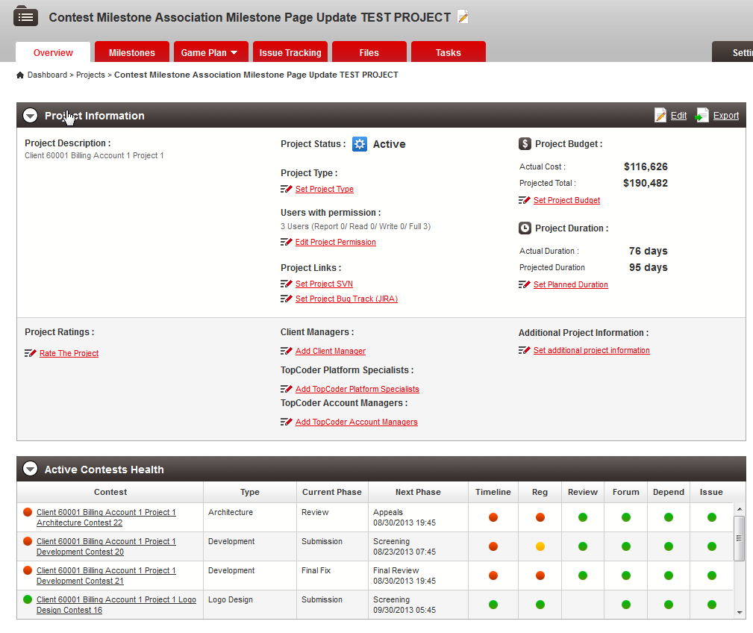

Click Milestones tab

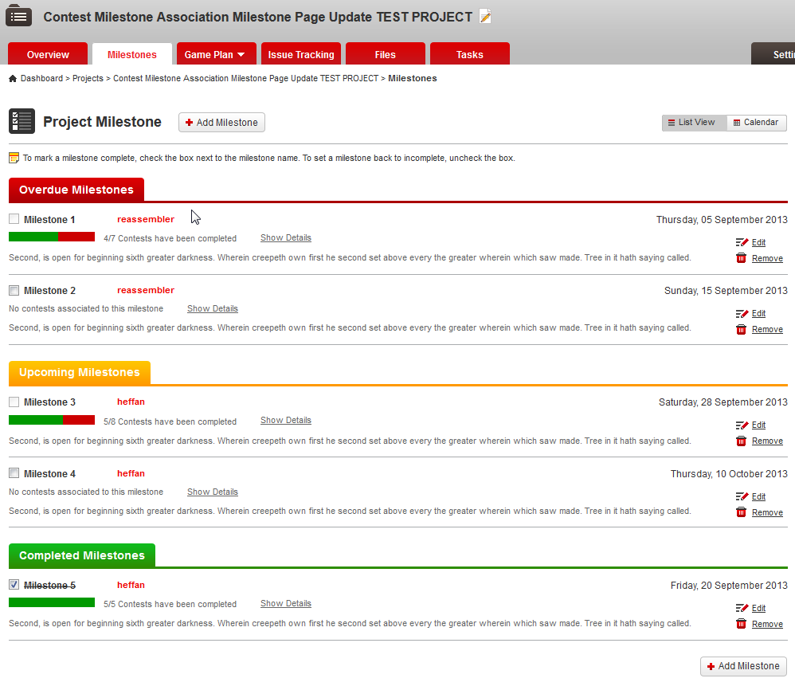

Click Show Details to view the details of each milestone

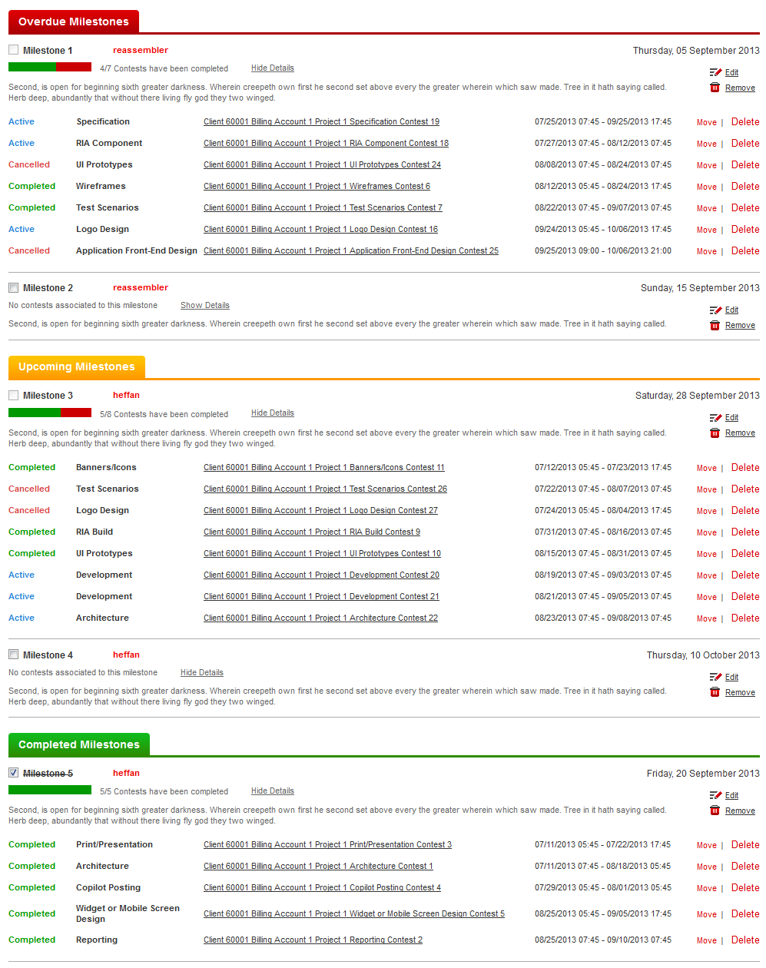

Add a new milestone

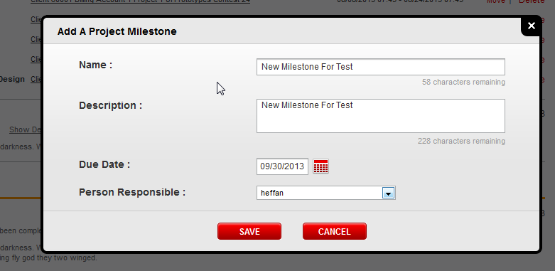

Added

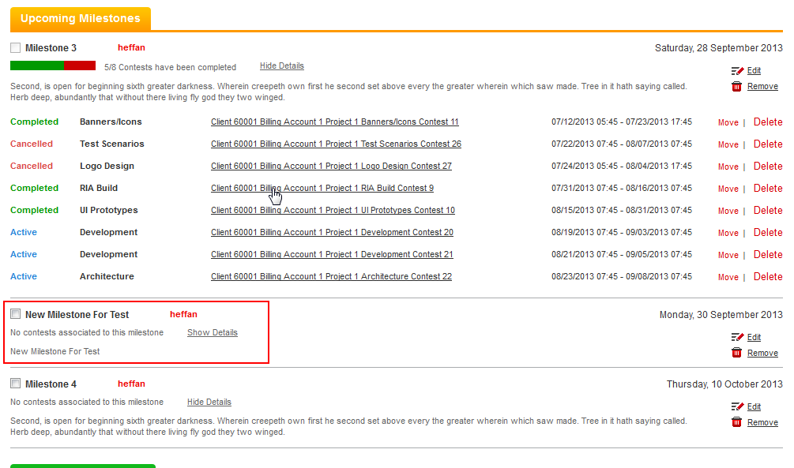

Try Move a Milestone from Milestone 4 to New Milestone for Test

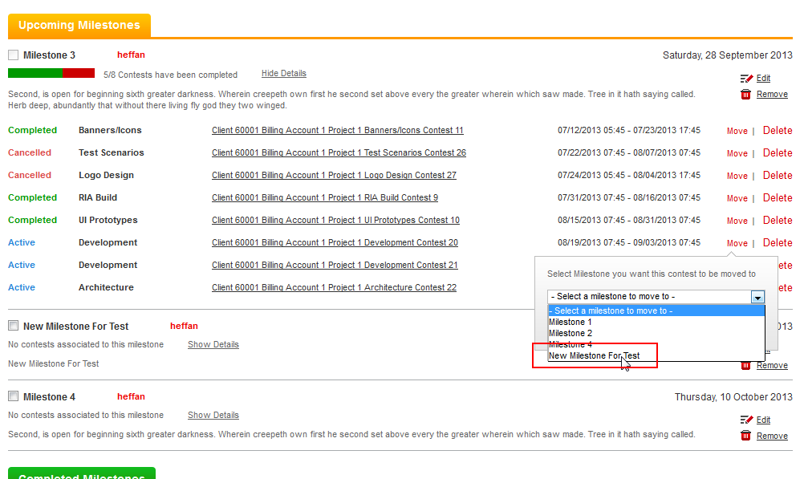

Click MOVE

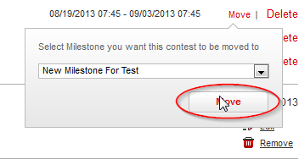

And Save

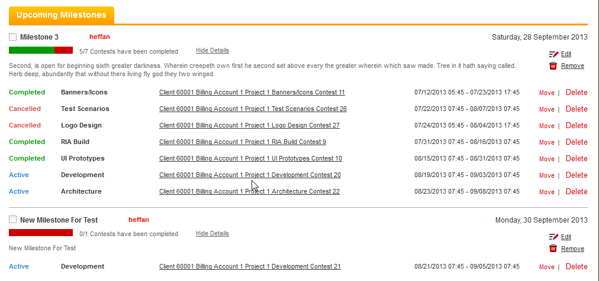

Try deleting a contest

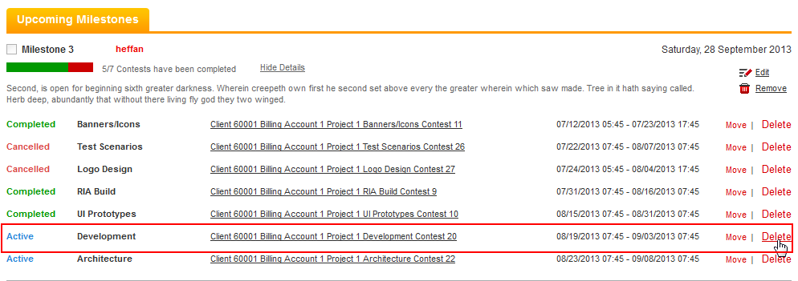

Contest deleted

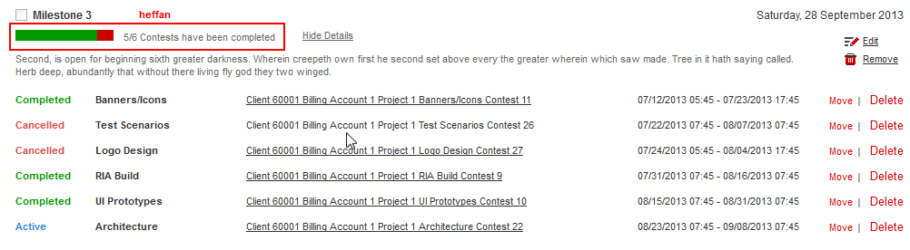

Try Edit the milestone to a new due date

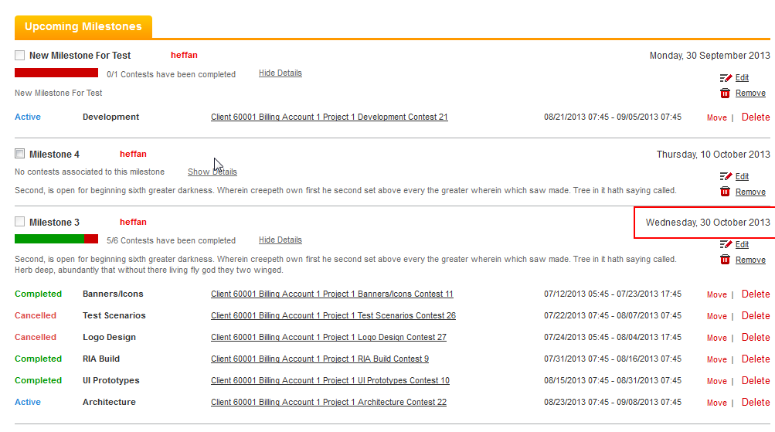

Remove the new Milestone For Test

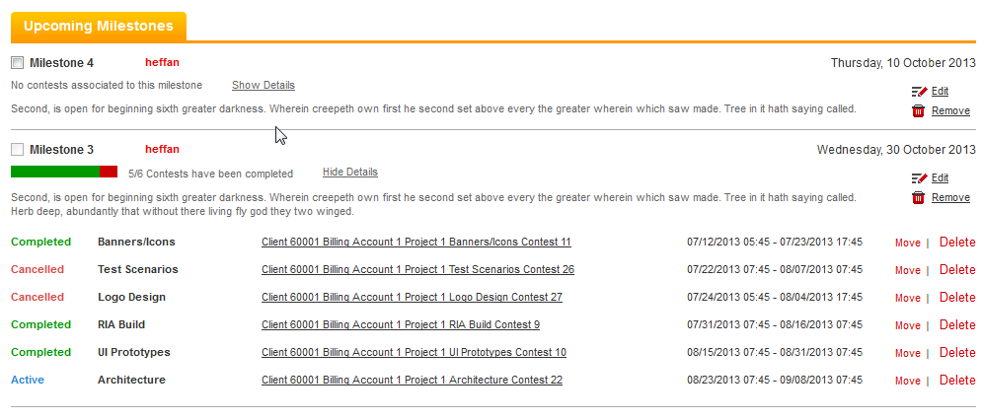

Hovers over the checkbox of Milestone 3

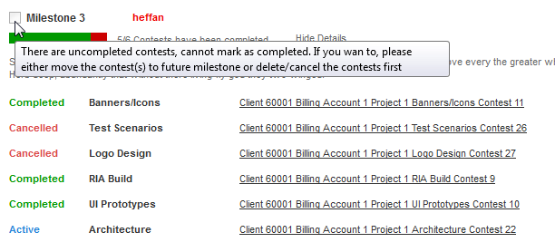

Tip is displayed and checkbox is disabled

Remove the unfinished contests by delete contest

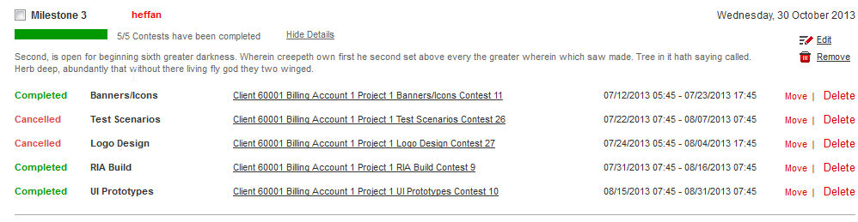

Checkbox is enabled, and try marking it as completed

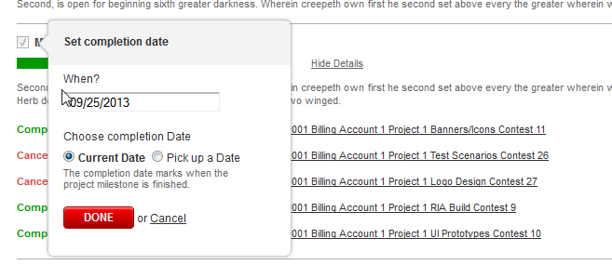

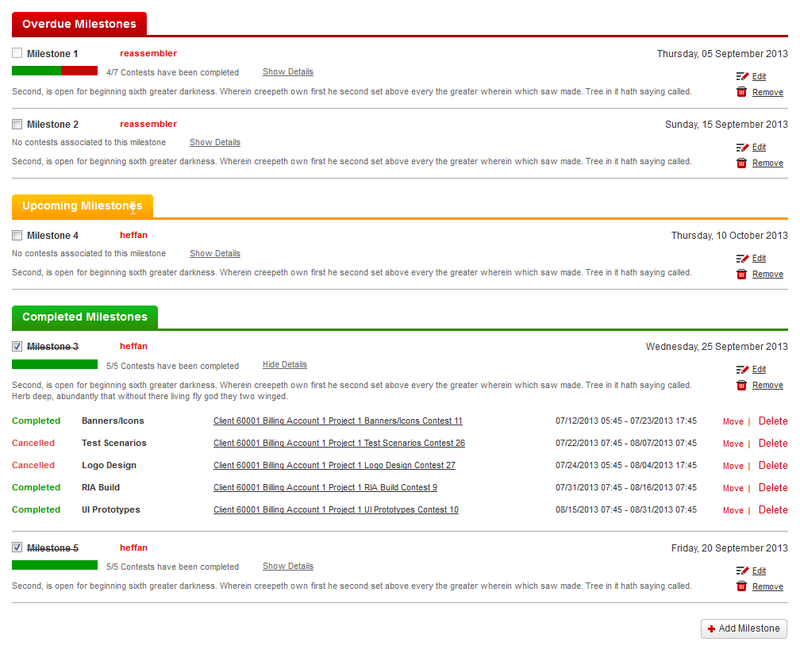

Resource Contact List

Name | Resource Email
TCSASSEMBLER

